Guideline for 2024 Winter Thesis/Dissertation Binding and Submission Process

Students who are eligible to be conferred a graduate degree in February 2024 should submit your thesis/dissertation to the University as follows:

1. Please Write in accordance with the attached form.
* Note
① Please enter the submission sheet date for thesis as "October 2023" and
the approval sheet date of thesis as "December 2023".
* Do not change the date.
② Please enter the year on the side of the cover as “2024”
③ Please use HY신명조, 휴먼명조 fonts.
If you use “Times New Roman” fonts, please increase the font size by 2P.
Good Cases Bad Cases
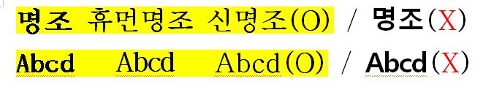
④ Please observe the fonts size, page layout.
⑤ Do not include acknowledgment.
⑥ If you do not submit your Thesis/Dissertation by online/offline within the designated period, the graduation will be postponed to the next semester. Additionally, if you cannot submit your Thesis/Dissertation in the next semester, the result of your final defense is cancelled and you should apply the final defense again.

2. ONLINE SUBMISSION

A. Period: ~ December 29, 2023, 17:00PM
B. How to submit (Refer to the Attachment)
1) Please go to the relevant website of http://dcollection.skku.edu
2) Click the Submission of materials button on the blue box.
3) Login the site with ID and Password (the same as Kingo Portal ID and Password)
4) Upload your PDF (or MS-Word) formatted thesis/dissertation.
※ Please include the Thesis/Dissertation Approval sheet without any names and signatures of Advisory Committee members.
5) Please finish up this online submission a day before the offline-submission due to the longer load-time for approval.

Online Thesis/Dissertation Approval sheet
(without any names and signatures)

3. OFFLINE SUBMISSION
A. Period: ~ January 5, 2024, 17:00PM
B. To where: (※ Please be sure to wear a mask when visiting the office)
General/Special/Professional Graduate School : Administration Office of Graduate School
C. How to submit
1) Prepare 3 copies of Soft/Hard Cover thesis/dissertation for the offline submission.
- 1 copy : with the original Thesis/Dissertation Approval sheet signed by all members of the Advisory Committee(containing both of names & signatures).
- 2 copies : with the blanked Thesis/Dissertation Approval sheet without name/signatures.
※ Hardcover is available only with Navy (짙은 네이비 포크로스) cover and letters in gold.(금박)
※ Softcover is available only with White(백색 모조지) cover and letters in black.
2) Please submit the thesis/dissertation with the following documents
① (Required) Confirmation of Thesis/Dissertation Contents Consistency(학위논문 내용 일치 확인서) ※ It is possible to use the attached form.
② (Required) Online submission certificate(학위논문 전자파일 제출 확인서)
※ It is possible to print out after approval from online submission site. (dCollection)
③ (Only Ph.D) (1) Complete the Questionnaire file and submit the Questionnaire document or (2) Visit the website (http://www.narastat.kr/emdh) & respond the Questionnaire, submit the “Questionnaire Completion form” (Refer the below detailed information)
④ (Only in the case If you need) Apply postponement of thesis/dissertation release
※ If you need postponement of thesis/dissertation release, please apply as follows:
Fill the form and obtain the signature of advisor and the Department Chair
▶ Apply through GLS System and upload the form
▶ Submit the original document with your thesis/dissertation to the Office of Academic Services
※ menu: GLS- 신청/자격관리>학위논문공개유예신청>학위논문비공개(공개유예)신청

OFFLINE 1 copy with name/signatures | OFFLINE 2 copies without name/signatures
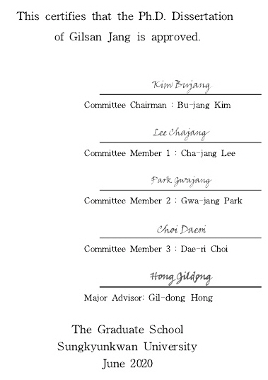 | 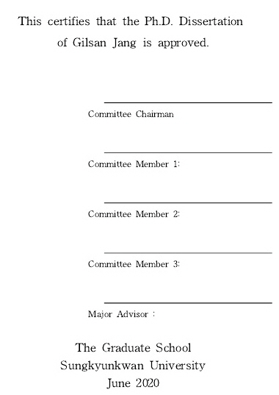

4. Questionnaire for 2024 Ph.D. Graduates (Ph.D. Only)
Students who are eligible to be conferred a graduate degree in February 2024 should submit questionnaire as follows (The questionnaire is organized by the Ministry of Education.)
1. Subject : Ph.D. Graduates(Including CMP) in February of 2024
2. Period : ~ January 5, 2024, 17:00PM
3. How to Submit : Choose one of the following ways and submit with your printed Thesis/Dissertation copies
1) Submit a completed the Questionnaire file (attached) (with Thesis/Dissertation) to the Office
2) Respond the survey of the following website (http://www.narastat.kr/emdh) and Submit the “Questionnaire Completion form” (with Thesis/Dissertation) to the Office of Academic.

* For more information on thesis/dissertation submission, please feel free to contact us as below.
- Online Submission: Samsung Library Office 031-299-4034, 4025
- Offline Submission: 1811-8585

