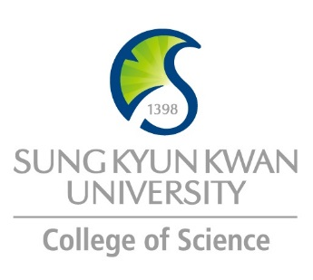 | Sungkyunkwan University (SKKU)  College of Science  Global Program Survey  2018 Spring

Institution | Bergische Universität Wuppertal
Country | Germany |  | City |  | Wuppertal
Webpage/ Social Media | www.uni-wuppertal.de / https://www.facebook.com/uni.wuppertal
Postal Address | Gauss-Str. 20, 42119 Wuppertal, Germany
Contact  Information |  | Primary |  | Secondary
 | Name | Inga STEINKAMP |  | Andrea BIECK
 | Position |  |  | Head of International Office
 | Function | Person in charge for incoming Exchange-Students at administrative level – International Office
 | Email | steinkamp@uni-wuppertal.de |  | bieck@uni-wuppertal.de
 | Phone | +49 (0)202 439 5139 |  | +49 (0)202 439 2181

Program | University Cooperation – Student Exchange
Period
Number of Exchange Places Offered | 1 semester exchange |  | 2 semesters exchange |  | Others
 | 4 |  | 2
Applicable Major | Biological Sciences | Mathematics |  | Physics |  | Chemistry
 |  | x |  | x |  | x
Level of courses applicable to Exchange Students = Non Degree Students | Undergraduate |  | Master |  | PhD
 | x |  | x |  | -
Fees | Tuition Fee |  | Other Fees
 | None |  | About €300 for travel ticket and student union per term
Academic Year | 2018/19
Academic Calendar | ACADEMIC YEAR 2018/19  Winter Semester (WS) 2018/19  Courses start: October 08, 2018.  Courses End: February 01, 2019  Summer Semester (SS) 2019  Courses start: April 01, 2019  Courses End: July 12, 2019
Credit System | See annex

Application Procedure | Look at: http://www.internationales.uni-wuppertal.de/en/incoming/international-students/exchange-students-from-buw-partner-universities.html
Application Guide
Requirements | Language | English: B1 – Intermediate level, German: A2 – Upper basic level
 | Academic
 | Others
Required Documents
Application Deadline | For winter semester 2018/19: July 15, 2018  For summer semester 2019: January 15, 2019
Nomination Deadline | For winter semester 2018/19: June 01, 2018  For summer semester 2019: December 01, 2018

Primary Language of Instruction | German | Secondary Language of Instruction, if any | English
Course Catalogue | For further information on courses, times and other events see  www.wusel.uni-wuppertal.de  If you have not yet enrolled at Bergische Universität, you can also view the course program without user name and password.
Courses Taught in English | For English courses check: “Search for courses taught in English”

Accommodation | Please send your application for a room in a student hall of residence to the International Office together with your admission application. The university cannot guarantee a room in a student hall for all exchange students. Rooms are allotted on a first-come-first-served basis. A furnished room (incl. Internet access) costs appr. € 236 per calendar month (pcm).  http://hochschul-sozialwerk-wuppertal.de/
Estimated Cost of Living | About €650 per month
Financial Aids | ---
Special Programs/Offers | ---
Expected Arrival Date | one week before beginning of lecture period
Number of Exchange Students per year | 2 from SKKU,, about 150 from other institutions | Diversity Exchange Students (Demographics) | worldwide
Useful Links | https://www.study-in.de/en/;https://www.wuppertal.de/microsite/en/index.php; www.internationales.uni-wuppertal.,de;http://www.international-students-wuppertal.de/wir-uber-uns/ ;

Note

