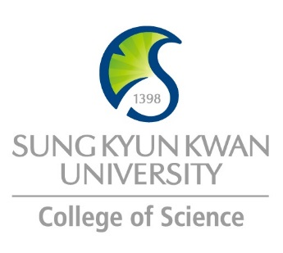 | Sungkyunkwan University (SKKU)  College of Science  Global Program Survey  2018 Fall – 2019 Spring

Institution | Sup’Biotech Paris
Country | France |  | City |  | Villejuif (20” from Paris)
Webpage/ Social Media | http://www.supbiotech.fr/en/index.aspx
Postal Address | 66 rue Guy Môquet, 94800 Villejuif
Contact  Information |  | Primary |  | Secondary
 | Name | Deborah FEDER |  | Picavet Sophie
 | Position | International Relations Assistant |  | Director International Relations
 | Function | In charge of Incoming students |  | Director International Relations
 | Email | deborah.feder@supbiotech.fr |  | sophie.picavet@supbiotech.fr
 | Phone | +33184071394 |  | +33180517102

Program | Biotechnology
Period | Fall, Spring, year
Number of Exchange Places Offered | 1 semester exchange |  | 2 semesters exchange |  | Others
 | 5 |  | 5
Applicable Major | Biological Sciences | Mathematics |  | Physics |  | Chemistry
 | x
Applicable Degree | Undergraduate |  | Master |  | PhD
 | x |  | x
Fees | Tuition Fee |  | Other Fees
 | NA (exchange) |  | NA (exchange)
Academic Year | Fall semester: Sept 1st –Dec 21st Spring: Feb 1st – July 14th
Academic Calendar | Fall semester: Sept –Dec/Jan Spring: Jan/Feb - July
Credit System | 1 semester = 30 ECTS (to be determined by the partner)

Application Procedure | https://goo.gl/forms/zlVEkqKylc6oBvRJ3
Application Guide | https://goo.gl/forms/zlVEkqKylc6oBvRJ3
Requirements | Language | Bachelor: Toefl 70(or equivalent) Graduate: Toefl 80 (or equivalent)
 | Academic | Background in Life Sciences, Biology, Biotechnology
 | Others
Required Documents | - Resume in English  - Cover Letter in English  - Copies of all diplomas/certificates you have earned  - Copy of your transcripts  - Copy of your passport  - Proof of French and/or English language proficiency
Application Deadline | Spring: October 30th – Fall: April 30th
Nomination Deadline | Spring: October 30th – Fall: April 30th

Primary Language of Instruction | English | Secondary Language of Instruction, if any | French
Course Catalogue | http://www.supbiotech.fr/en/curriculum/academics-third-year
Courses Taught in English | Last year of bachelor (3rd year), 2 years of master (4th and 5th year)

Accommodation | Possibility of dormitory
Estimated Cost of Living | Rent: 650€ average
Financial Aids | CAF (aids for housing)
Special Programs/Offers | Summer Program: Stem Cells, Food Science, Cosmetics
Expected Arrival Date | Spring: January 30th ; Fall: September 1st
Number of Exchange Students per semester | 5 | Diversity Exchange Students (Demographics)
Useful Links | http://www.summer-schools.fr/supbiotech/index.html

Note

