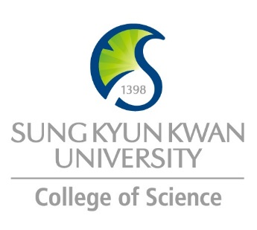 | Sungkyunkwan University (SKKU)  College of Science  Global Program Survey  2018 Summer – 2019 Spring | 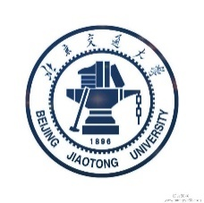  School of Science

Institution | School of Science, BJTU
Country | China |  | City |  | Beijing
Webpage/ Social Media | http://cie.bjtu.edu.cn/en/ http://en.bjtu.edu.cn/
Postal Address | Beijing Jiaotong University,No.3 Shangyuancun, Haidian District, Beijing, China; 100044
Contact  Information |  | Primary |  | Secondary
 | Name | Ying Zhao |  | Haiyan Wu
 | Position | Foreign Affairs Assistant |  | Foreign Affairs Assistant
 | Function | Foreign Affairs |  | Foreign Affairs
 | Email | zhaoying@bjtu.edu.cn |  | hywu@bjtu.edu.cn
 | Phone | 8610-51688700 |  | 8610-51688373

Program | Nanomaterials and Technology
Period | 1 semester or 1 year
Number of Exchange Places Offered | 1 semester exchange |  | 2 semesters exchange |  | Others
 | 10 |  | 5 |  | Please specify
Applicable Major | Nanomaterials and Technology | Mathematics |  | Physics |  | Chemistry
 | √ | √ |  | √ |  | √
Applicable Degree | Undergraduate |  | Master |  | PhD
 | √
Fees | Tuition Fee |  | Other Fees
 | None |  | None
Academic Year | 2019 AY: Feb.25, 2018-Jan.14, 2020 (Subject to Change)  2018 AY: Mar.5, 2018-Jan.18, 2019
Academic Calendar
Credit System | 4.5

Application Procedure | Home institution nomination  Online application: http://study.bjtu.edu.cn/member/login.do
Application Guide | http://cie.bjtu.edu.cn/en/  http://cie.bjtu.edu.cn/file/c17a5776-7d12-4484-9db9-457fa2eb6c0d.pdf
Requirements | Language | English(TOEFL 68 or IELTS 5.5)
 | Academic | GPA (Grade Point Average) above 2.7 / 4.0 or 3.0 / 4.5 or 3.3 / 5.0
 | Others | Completion of at least one year study in home institution
Required Documents | - Legitimate photograph  - Valid passport with personal identification page  - Certificate of enrollment for the degree an applicant is currently seeking  - Academic transcript with cumulative records until the time of application
Application Deadline | Spring semester: Dec.30  Fall semester: Jun.30
Nomination Deadline | Spring semester: Nov.30  Fall semester: May.31

Primary Language of Instruction | Chinese | Secondary Language of Instruction, if any | English
Course Catalogue | Please find the Catalogue in the attached
Courses Taught in English | Please find the course list in the attached

Accommodation | http://cie.bjtu.edu.cn/en/1.aspx?id=81  http://cie.bjtu.edu.cn/file/a8f7d237-f63f-4842-bdec-d13c23338cf8.pdf
Estimated Cost of Living | http://cie.bjtu.edu.cn/en/1.aspx?id=203 (2500RMB/month/undergraduate student)
Financial Aids | Beijing Municipal Government Scholarship http://cie.bjtu.edu.cn/en/1.aspx?id=128
Special Programs/Offers | Beijing Jiaotong University 2016 Summer Short Term Courses  http://cie.bjtu.edu.cn/en/1.aspx?id=157
Expected Arrival Date | Spring semester: Feb.25 (Subject to Change)  Fall semester: Sept. 1 (Subject to Change)
Number of Exchange Students per semester | 5 | Diversity Exchange Students (Demographics)
Useful Links | http://cie.bjtu.edu.cn/en/default.aspx

Note

