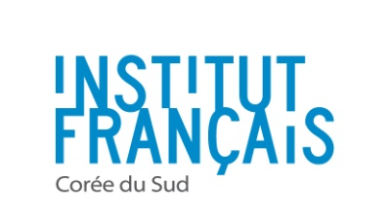
OFFRE DE STAGE

I - INFORMATIONS GENERALES SUR L’ENTREPRISE
Nom : Attali & Associés Korea Ville / lieu (quartier): Seoul Yeoido Nombre de salariés : 1
Site internet :
Présentation de la société :
Attali & Associés is an international consulting firm, investment bank and private equity vehicle specializing in the development of European IT start-ups, from software to genomics. The firm was founded in 1994 by Jacques Attali, Chairman of A&A, Professor, writer, special advisor to French President François Mitterrand (1981-1991), founder and first president of the European Bank for Reconstruction and Development (1992-1993)
About Attali & Associés Korea
The Korean office of Attali & Associés was created in April 2014. It is headed by Pierre Joo, who has a double French-Korean culture and a solid business background (ESCP Europe, Finance Major).
Pierre Joo has been a close collaborator of Jacques Attali for 13 years and has been advising A&A’s clients on their Korean projects that ranged from business development and technological partnership to merger & acquisitions.

A&A Korea’s main activity: building long-term partnerships across continents
Guiding European companies in their Korean operations
Identification of business opportunities to help European companies undertake high added-value operations in Korea. Monitoring of market trends across continents and of technological evolutions to help identify the most strategic partners and investment opportunities.
In-depth knowledge and understanding of the Korean context, from the public and the private sector points of views.
Guiding Korean companies in their European operations
Identification of business opportunities to help Korean companies undertake high added-value operations in Europe. Monitoring of market trends across continents and of technological evolutions to help identify the most strategic partners and investment opportunities.
In-depth knowledge and understanding of the European context, from the public and the private sector points of views.

II - STAGE
Description des tâches :
The Intern will be in charge of tasks equivalent to that of a junior consultant :
Commercial prospection :
- Market research and monitoring
- Preparation of commercial proposals
- Meeting and networking event attendance
Service Provision
- Preparation of client deliverables
- Preparation of meetings
- Relationship management at operational level
Administrative and back office tasks
Formation(s) souhaitée(s) :
Business with major in international trade and/or management consulting

Compétences souhaitées :
Good knowledge of French business and economy
Appetite for digital, mobile technologies and innovation
Rigorous
Efficient
Pro-active
Not afraid of ambitious challenges
Autonomy
English proficiency is a must
French proficiency is a plus
Proficiency in Ms Excel & Powerpoint is a must
Début du stage: 01/12/2015 Fin du stage: 01/06/2016
Durée : Intensité horaire :
Rémunération et/ou indemnités (éventuelles) : open to discussion
III – DEMARCHE POUR PRESENTER SA CANDIDATURE
Documents demandés : Choose an item. CV + Cover letter
Contact :
- Nom : Pierre Joo
- Poste : Representative
- Email : pjoo@attali.com
- Téléphone :

Date limite de candidature : 30/11/2014

