Nanomedicine via Smart SANDs, EXODUS, and Brain Organoid MAP

Luke P. Lee
Harvard Medical School
Harvard Institute of Medicine, Brigham Women’s Hospital
Institute of Quantum Biophysics, Department of Biophysics, SKKU

Abstract

In this talk, I will present how to gaze at the health status of humanity and the Earth in a grain of sand and find solutions for preventive precision medicine against a global pandemic such as COVID-19. Quantum plasmonic-based speedy analytical nano-optofluidic diagnostic systems (SANDs) can help us to predict and stop the spread of infectious diseases. As an example of smart SANDs, integrated molecular diagnostic systems that comprise three key elements are developed: (1) self-contained sample preparation and liquid biopsy on-chip, which allows a rapid sample-to-answer readout platform; (2) ultrafast quantum plasmonic amplification of DNA, RNA, and protein biomarkers; (3) interface of smartphone optical system.
I will also discuss exosome detection via the ultrafast-isolation system (EXODUS) for nanomedicine. The EXODUS by harmonic piezoelectric resonator and nanoporous membrane allows automated label-free purification of exosomes from various biofluids, including blood, tears, urine, and saliva. EXODUS will enable us to gain high sensitivity, specificity, and accuracy of liquid biopsy. For example, the significantly improved purification of exosomes from cancer patients’ urine samples allows us to efficiently get exosomal RNA profiling or proteomics and compare enriched pathways of kidney and bladder cancer.
For personalized precision nanomedicine, I will present the development of brain organoid microphysiological analysis platforms (MAP) on-chip with nano-biological quantum sensors and therapeutic modulations, which will benefit from predicting the most effective treatment of diseases for each patient. Human-induced pluripotent stem cells-based brain organoid MAP provides an ideal model to address fundamental questions of neuropathogenesis and find solutions for neurodegenerations. In addition, patient-derived brain organoids can recapitulate patient responses and help personalized medicine. Smart SANDs, EXODUS, and organoid MAPs will impact quantitative life sciences and precision nanomedicine through the convergence of biology, chemistry, physics, and engineering.

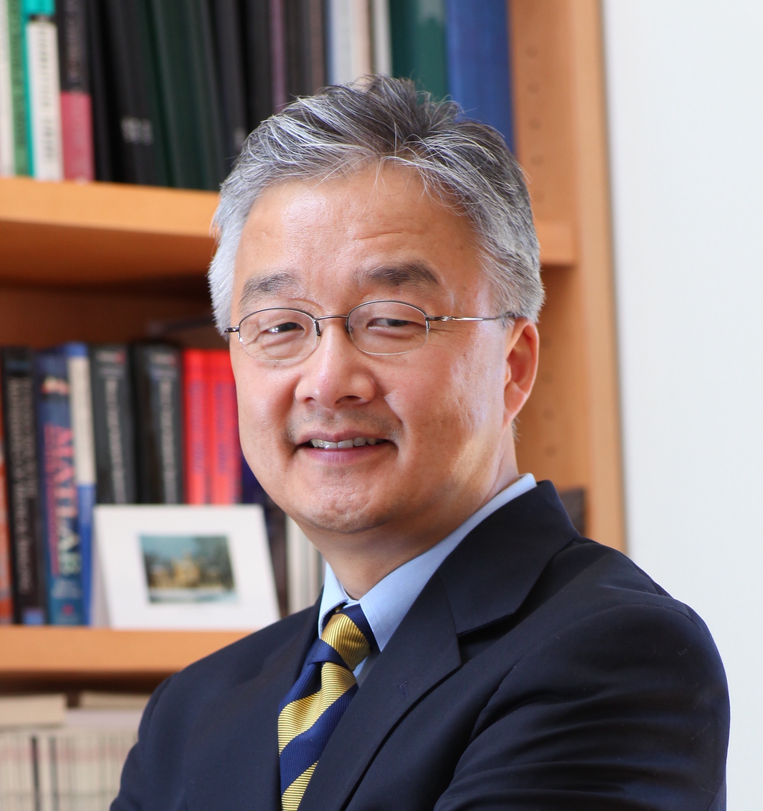
Prof. Luke P. Lee received his BA in Biophysics and Ph.D. in Applied Physics and Bioengineering from UC Berkeley. He joined the faculty at UC Berkeley in 1999 after more than a decade of industry experience. He became the Lester John and Lynne Dewar Lloyd Distinguished Professor and Arnold and Barbara Silverman Distinguished Professor at Berkeley. He also served as the Chair Professor in Systems Nanobiology at ETH Zürich from 2006 to 2007. He founded the Biomedical Institute for Global Health Research & Technology (BIGHEART). He served as Associate President (International Research and Innovation) and Tan Chin Tuan Centennial Professor at the National University of Singapore from 2016 to 2018. Currently, he is a Professor of Medicine at Harvard Medical School. He also founded the Institute of Quantum Biophysics at Sungkyunkwan University, Korea. He is a Fellow of the Royal Society of Chemistry and the American Institute of Medical and Biological Engineering. His work at the interface of biological, physical, and engineering sciences for medicine has been recognized by many honors, including the IEEE William J. Morlock Award, NSF Career Award, Fulbright Scholar Award, and the HoAm Prize. Lee has over 350 peer-reviewed publications and over 60 international patents filed. His current research interests are quantum biological electron transfer in mitochondria and living organisms, the early detection of infectious and neurodegenerative diseases, and the neurogenesis of brain organoids.

